

Intersectionality 101

*Figure 8 Consulting*

DATE:

Thursday, Oct. 18, 2018

TIME:

10:30 to 11:30 a.m.

LOCATION:

Wright Auditorium

Join the **Center for Diversity and Health Equity** for a fast-paced, interactive workshop exploring what happens when complex cultural identities — your own and those of patients and families — collide in the healthcare setting.

April Lewis and Carol French, cofounders of Figure 8 Consulting, have more than 20 years of experience in cultural agility, diversity and intercultural organizational development. Their presentation will help you:

* Define intersectionality in the context of healthcare.
* Examine the impact of intersectionality on health outcomes.
* Explore the advantages and disadvantages of each person’s unique, multi-dimensional life experiences.

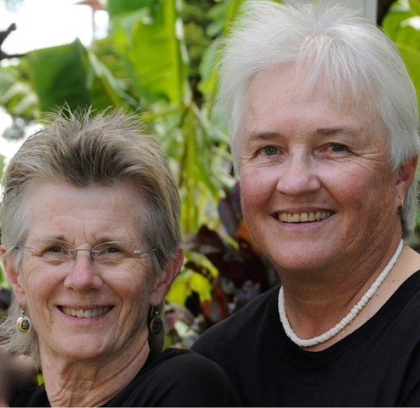

A light brunch will be provided.

Can’t make it to Wright? Tune in virtually from within Children’s network at <mms://ppwrst01/wright>.

*This event is open to the community. For those joining from outside of Children’s please arrange to arrive ten minutes early to register with the security desk at the River 3 entrance.

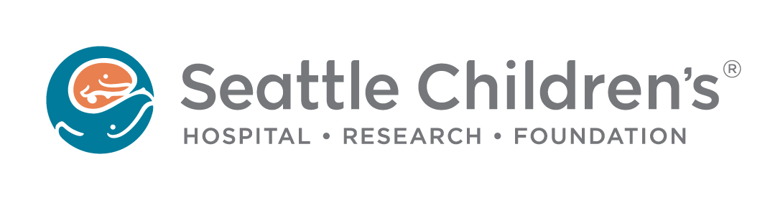

**Learn More!**

Visit the [Center for Diversity and Health Equity](http://child.childrens.sea.kids/People_and_Places/Departments/Center_for_Diversity_and_Health_Equity/) on CHILD.